HTTP 1.0 Vs HTTP 2.0
HTTP 1.1 | HTTP 2.0
HTTP/1.0 allowed just one request to be made at a time | HTTP 2.0 allows multiplexing and concurrency
File loading was done sequentially only | It is done in any random manner
Each assest like cookies have thier own headers and each request takes separate round trip | It is done in single request here
HTTP 1.0 transfer is textual | Transfer is binary
Server pushing is not possible with HTTP 1.0 | With HTTP 2.0, a server can push resources to the client even without the client requesting them, just because it knows that the client will end up needing them.

RESTful Architecture:-
Representational State Transfer (REST) is a style of architecture based on a set of principles that describe how networked resources are defined and addressed.
Representational state transfer (REST) or RESTful web services is a way of providing interoperability between computer systems on the Internet. REST-compliant Web services allow requesting systems to access and manipulate textual representations of Web resources using a uniform and predefined set of stateless operations. Other forms of Web services exist, which expose their own arbitrary sets of operations such as WSDL and SOAP.

It is important to note that REST is a style of software architecture as opposed to a set of standards. As a result, such applications or architectures are sometimes referred to as RESTful or REST-style applications or architectures.

An application or architecture considered RESTful or REST-style is characterized by:
- State and functionality are divided into distributed resources
- Every resource is uniquely addressable using a uniform and minimal set of commands (typically using HTTP commands of GET, POST, PUT, or DELETE over the Internet)
- The protocol is client/server, stateless, layered, and supports caching

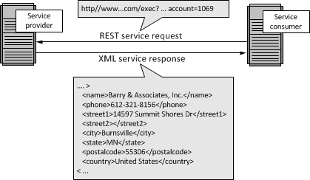

HTTP Codes:
1xx Informational responses.
2xx Success.
3xx Redirection.
4xx Client errors.
5xx Server errors.

